**Residuals Plots**

The x-axis represent the fitted values, or what would be expected to be seen on the y-axis of a normal scatter graph.

There is a direct relationship between the fitted values and the original x-values when a linear model is fitted, but this is done because it works best when looking at non-linear models, as the x and y variables are on the same scale.

This is based of the model that is used in iNZight, minitab, and most other statistical packages... so if students go on and study statistics any further this is what they will come across.

Below is the output from NZGrapher on the left, and iNZight on the right.

[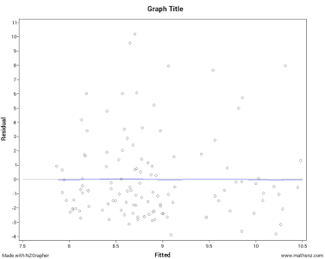](https://sites.google.com/a/mathsnz.com/maths-nz/blog/residualsplots/unnamed.png?attredirects=0)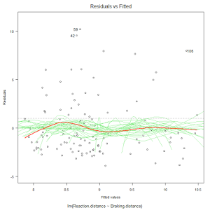

Hopefully that is helpful to everyone.

Jake Wills   
[jwills@mathsnz.com](mailto:jwills@mathsnz.com)